Executive Summary
Haibrid's file upload feature allows users to upload various file formats (.doc, .pdf, .xlsx, etc.) to use as sources within the platform. This streamlines workflows by centralizing resources, improving productivity, and simplifying access to external data.
File upload will allow users to store, share, and quickly retrieve a variety of information sources within selected workspace and projects and quickly retrieve them.

Concept Doc | https://docs.google.com/document/d/1pNaVvOXMMmCHc1IMEInMjezuawlylQSHFALi1vq-pGw/edit
Figma Link | https://www.figma.com/design/n2FYTev0A6bT7CCK3626BR/Haibrid-DS-v1.2?node-id=8194-9459&m=dev
Loom Link | https://www.loom.com/share/d8d613e6b6ad45bb8fab26728e169249
Document Status | {Ready}
Owner | OS

Objective
The purpose of this project is to implement a file upload feature, enabling users to upload and store various file formats (e.g., .doc, .pdf, .xlsx) within their workspaces/projects. This feature aligns with Haibrid’s strategic goal of improving workflow efficiency by centralizing resources in one platform, simplifying data access, and enhancing user productivity.

Assumptions
- Users may need to save relevant multimedia files within specified projects together with URLs
- Users prefer simple and intuitive file upload process
- Users may need basic instructions to be aware of file format and other restrictions

Success metrics
List project goals and the metrics you'll use to judge its success

Goal | Metric
e.g., Simplify the user experience | e.g., Customer satisfaction score increases

Requirements
- File Formats Supported: The system should support .doc, .pdf, .xlsx formats.
- Max File Size: The maximum file size per upload is 50 MB.
- Upload Limits: Users have a total upload size cap per user to be decided.
- UI/UX Elements:
- “Add Source” button with a “paper clip” icon for file uploads.
- Hover tooltip indicating file format support and size limits.
- Warning modals for interrupted uploads, unsupported file types, and file size limits.
- Snackbar notifications for errors like “Upload Error” and “Unsupported File Type.”
- Drag and drop file functionality with format and size validation.

User interaction and micro-interactions requirements
- In the Project details page, by the “Add Source” button, the user should see a “paper clip” icon which stands for uploading files.
- While hovering over this button there should be a tooltip, saying: “Click to attach files (.doc, .txt, .pdf, and more)”.
- When the project has no sources yet, there should be an empty state message saying: “Click “Add Source” to add sources or use the attach button to add files (max size: XX mb). You can also drag and drop files here.”
- When clicking on the “paper clip” icon, the computer download manager should open, with the supported files active (all file formats like .zip that we do not support should not be selectable).
- Once a file is selected, it should appear in the project sources list in a loading state.
- As soon as all the information is fetched from the file (the format and the name), the file card should have its final state.
- When the user tries to close the tab while the file is being uploaded, they should see a warning modal, saying: “If you leave this tab, your file upload will be interrupted.”.
- When the user tries to upload a file that exceeds the max allowed file size, they should see an informative snackbar saying: “Max Size: 50 MB”, and the upload should not take place.
- When the user tries to upload a file, but they have reached the max upload total size per user, they should see an error snackbar saying: “Upload Limit Reached”, and the upload should not take place.
- If any error occurs while uploading the file, and the upload is interrupted, the user should see a snackbar, saying: “Upload Error”.
- If the user tries to drag and drop a file that has a format we do not support, they should see a snackbar message, saying: “Unsupported File Type”
- As soon as the file is successfully uploaded, it should look like the rest of the source cards, with a corresponding icon, and it should have all the actions as the rest of the source cards do (in the three dots menu), and, additionally, it should also have the “Download File” option.
- When clicking on the “Open in New Tab” option, the file should be previewed in a separate tab.

User interaction and design
The file upload feature will be placed in the Project Details page beside the "Add Source" button.
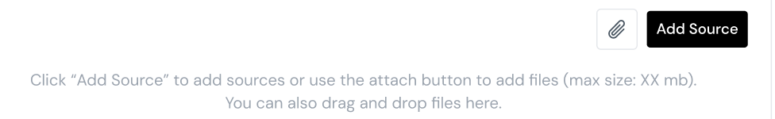

The user should experience a seamless process with visual feedback (e.g., tooltips, snackbars, loading states).

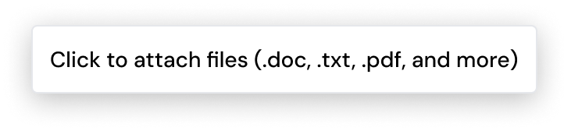
Once a file is uploaded, it should be visible as a source card with standard options such as previewing in a new tab or downloading.
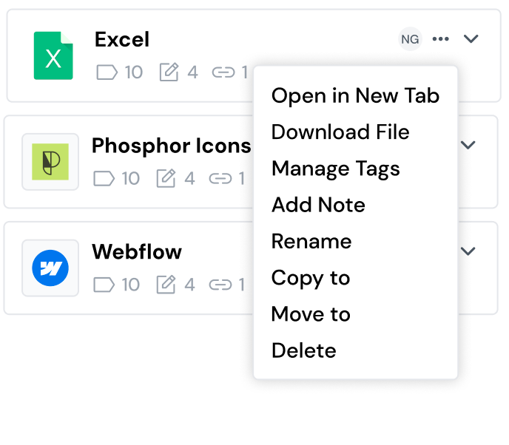

Open Questions
- What is the total upload size limit per user (currently undecided)?
- Should there be a custom view for file previews?
- Should we allow folder uploads in the future, or keep it limited to individual files?

Out of Scope
- out of scope is attribution for file-based sources, this means that the attribution search bar within the document editor should not display sources that have been uploaded by the user

